Broomhill Infant School

Beech Hill Road
Sheffield S10 2SA
Tel/Fax: 0114 2660936
E-mail: enquiries@broomhill.sheffield.sch.uk

Website: http://broomhill.sheffield.sch.uk

Head teacher: Jane Barnes
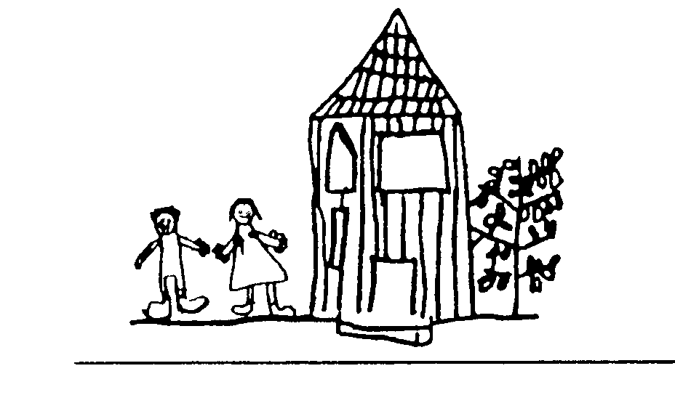

24 January 2025
Dance After School Practise – Year 1 and Year 2
Dear Parent/Carer
There are 20 places available for the dance practise running on Mondays after school, 3-4pm. The practise sessions will be running for 6 weeks (24 Feb – 14 Apr 2025).
The children will be learning a routine in preparation for performing at the Octagon Dance Performance in April. Tickets for this event will be available via a link which will be shared with the parents at a later date.
The club will be run by Mr Clarke (class teacher of Blue Base).
There is no cost for this club.
Please return the slip below to register your interest for your child to attend these practise sessions on the understanding that you consent your child performing at the Octagon in April 2025.
--------------------------------------------------------------------------------------------
Dance club Y1 and Y2 – 24/2 – 14/4 (6 weeks)
My child ………………………………………………………………………… Base…………………………………… would like to join the Dance Practise on Monday after school.
I consent to my child joining the practise sessions in preparation for performing at the Octagon in April 2025.
Parent/Carer: Print name……………………………………………………………………………………………….
Signed ………………………………………………………………………………………………………………………………..

