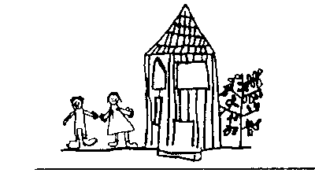
Broomhill Infant School

The EYFS Framework Rationale

EYFS Framework Rationale

We know that we have covered the seven areas of learning from the EYFS Framework Educational Programme because we have broken them down into smaller steps sequenced across the year as per Development Matters.
The small steps are then placed into topics that focus on the context of Broomhill and reflect the needs of our learners.
We understand that, for some subjects, our children need formal, carefully sequenced input. In the main, practitioners support pupils within the provisional with the aim of developing PSED skills and the necessary language required to provide them with a quality foundation upon which they can build.

