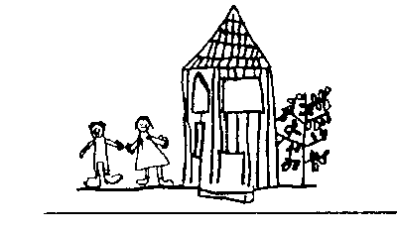
Broomhill Infant School

The KS1 Curriculum Rationale

KS1 Curriculum Rationale

How do we know that we’ve covered the N.C?
- Subject leaders mapped the National Curriculum into their Progression of Knowledge and Skills.
- As a team, we used the Progression of Knowledge and Skills to plan a two-year cycle. We did this by physically mapping out the National Curriculum strands onto a two-yearly plan.
- We then worked alongside our Forest School practitioners to identify the subjects that would be enhanced and enriched by the outdoor environment. This was then carefully woven into our medium-term plans.
- The Key Stage 1 lead used the Learning Challenge Curriculum approach to organise the children’s questions to bring the curriculum to life.
- Our two-yearly cycle allows for frequent retention and recall opportunities and these are mapped into the medium-term plans for each subject.
- The teachers use a range of formative assessment strategies to monitor teaching and learning.
- Our two-yearly cycle allows children more opportunities to deepen their knowledge and understanding.
- Forest School is the Golden Thread uniquely enriching our curriculum.

