Broomhill infant School Self-Evaluation Form

Self-Evaluation Summary
Area | Judgement
Overall Effectiveness | GOOD
Quality of Education | GOOD
Behaviour and Attitudes | GOOD
Personal Development | GOOD
Leadership and Management | GOOD
Early Years Foundation Stage | GOOD

School Context
At Broomhill Infant School we are an enthusiastic, caring and co-operative team. We ensure a safe and secure environment that is welcoming to all. All our pupils are encouraged to achieve their best within an enriching, enjoyable and relevant curriculum with creativity at its heart. We celebrate diversity by learning from each other, and prepare our pupils to develop the skills and attitudes they will need for a happy and fulfilling life. By the time the pupils leave us at the end of Year 2, our goal is that they are well-rounded citizens who are considerate, tolerant, inclusive and have a good understanding of the world around them as well as having the knowledge and skills required to be successful as they navigate their way through further education and life as an adult.

Broomhill Infant School is a one form entry 4-7 age school, with a capacity of 120 pupils. Currently, there are 118 pupils on roll. The proportion of pupils eligible for free school meals is 12% compared to 17.2% nationally. 38% of pupils have English as an additional language compared to the national average of 19.5%. 2.5% of our pupils supported with an education, health and care plan is below the national average 4%. The proportion of pupils who receive SEN support is less than national average of 12.6% at 9%.

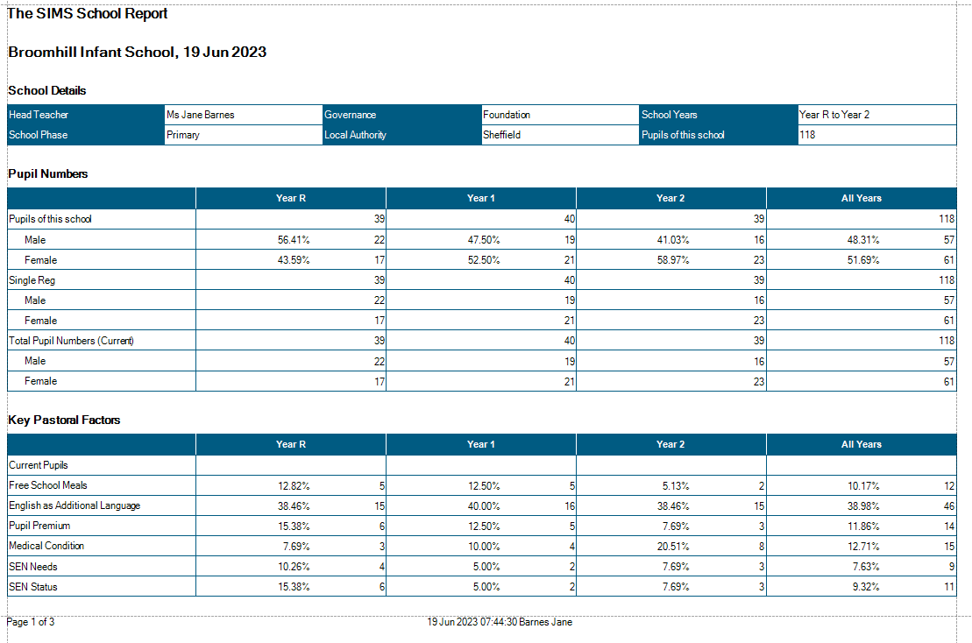

Most Recent Ofsted Inspection
Date | 27.06.2011
Overall Judgement | Outstanding

Improvements since Previous Ofsted
Key Issues | Developments Made and Impact
Increase the opportunities for pupils, especially the more able, to undertake investigations and research. | Each pupil has one day of Forest School per week. This has increased opportunities for pupils to investigate and explore.
 | In addition, pupils have learned the necessary skills to research existing products using the Chrome Books.
 | Our wider curriculum lends itself to investigation and exploration and is explicitly linked to our pupils’ Forest School experience.

Curriculum Statement
Broomhill Infants School offers a highly innovative and child-centred curriculum - ‘The Learning Challenge Curriculum’. The curriculum is built on sequencing knowledge and skills to include substantive and disciplinary knowledge and builds on prior learning so that each subject creates a narrative. We are clear about what we want our pupils to be able to do, know and remember by the time they leave our school. We have also mapped out what the pupils will need to know moving forward in Year 3. Much of this information will be drawn from the National Curriculum, whilst also considering Broomhill’s context, including issues arising from our pupils’ cultural capital and the locality of the school. Our curriculum has an enquiry-based ethos which aims to deepen thinking, improve oracy and which puts questioning at its heart. The pupils are asked at the end of the academic year to think of questions that might inform our half termly planning.

The school’s curriculum has been designed to:

- Consider the diversity of our lovely families
- Consider the suburb of Broomhill
- Consider the wider world
- Be progressive, both in skills and in knowledge
- Consider the pupil voice
- Consider stakeholders voices

Cultural Capital – we are extremely fortunate to be a part of a richly diverse community here at Broomhill and therefore valuable cultural knowledge is at the heart of all that we do. We invite parents in from different faiths and religions to enrich our knowledge and to give us a better understanding of one another. We celebrate our similarities and differences and the world map in the foyer demonstrates our diversity as a school community. By the time the pupils leave us at the end of Year 2, our goal is that they are well-rounded citizens who are considerate, tolerant and have a good understanding of the world around them as well as having the knowledge and skills required to be successful as they navigate their way through further education and life as an adult.

Our values are the secret to our success and they are plotted out on our roadmap which tells us when we are focusing on each of the values:

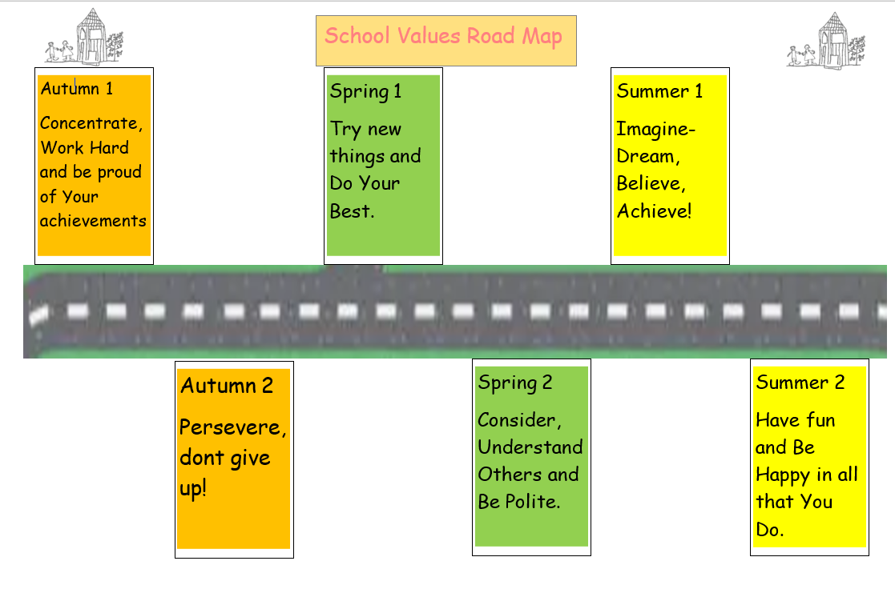

Quality of Education - Intent
Judgement | GOOD

Evidence | Impact
Our intent is that the curriculum is engaging, exciting and enriching with creativity at its heart. | The impact is that the pupils are enthused to learn and therefore do more, end up knowing more and remember more.
The curriculum is continually being refined to ensure that in every subject’s long-term plan - skills, knowledge and understanding are progressively and logically sequenced. The Medium-Term Plans will effectively map out the progressive knowledge across a number of weeks in a half term and the Forest School provision, which is the Golden Thread that weaves through our curriculum, is explicitly linked to what the pupils need to know. | Knowledge has been logically sequenced and builds upon the previous knowledge. The impact is that, as children revisit the knowledge thereby remembering the previous learning whilst also building up new knowledge.
Enrichment events will be carefully chosen to match the learning and will be written into the planning so that any teacher can pick up the planning and have an overview of how everything fits together as well as detailed weekly planning. | Enrichment is a key part of the learning. Pupils are hugely motivated by enrichment events and this has improved behaviour during unstructured times as well as slightly improving attendance. This has helped pupils remember their learning and therefore, they will know more over time and, hence, when it gets revisited, prior knowledge will be built upon. School staff are determined that every child will achieve their best and receive maximum benefit from innovative and unique learning opportunities
Positive mental health and well-being continues to be a major focus. We intend to promote a growth mindset where the pupils believe that they can achieve their goals eventually. | Pupils are confident and articulate. They have a healthy sense of well-being and a positive outlook. An emphasis on a sense of belonging (to school and the community) is woven into all aspects of learning.
‘Continuous Provision’ will also feature in each class base, from FS2 to Y2. | Child initiated activities in continuous and enhanced provision has facilitated opportunities to deepen understanding and to commit concepts to long term memory
Cultural Capital – we are extremely fortunate to be a part of a richly diverse community here at Broomhill and therefore valuable cultural knowledge is at the heart of all that we do. We intend to invite parents in from different faiths and religions to enrich our knowledge and to give us a better understanding of one another. community. By the time the children leave us at the end of Year 2, our goal is that they are well-rounded citizens who are considerate, tolerant and have a good understanding of the world around them as well as having the knowledge and skills required to be successful as they navigate their way through further education and life as an adult. | We celebrate our similarities and differences and the world map in the foyer demonstrates our diversity as a school  By the time the children leave us at the end of Year 2, they are confident, with a healthy sense of self and a positive outlook. They are considerate, tolerant and have a good understanding of the world around them as well as having the knowledge and skills required to be successful as they navigate their way through further education and life as an adult.
Pupils will have access to a wide range of extra - curricular activities that deepen and enrich learning.  Parents have asked for more music and, in September we will be working with the music hub for assemblies and a choir after school. | We have small groups for those children who have been identified by teachers as needing something extra. The impact of asking the children is that we now have  Cooking, Sports, Music, Science, Art, Yoga, Sewing, football, Poetry, Colouring, Skipping, Dancing and Gardening which all build self-esteem, physical and mental wellbeing and develop transferable skills.

Next Steps - Linked to School Improvement Plan
Continue to refine the curriculum by plan, do, review using the monitoring cycle and curriculum leader judgement to assess the next steps.

Extending enrichment so that all pupils have the chance to join a club either in the morning before school, at playtime, dinner time or after school. We want to consider pupil voice when enlisting new enrichment activities. We would like to know pupil’s interests outside of school so that we can enhance and extend this experience.

Create pen profiles for the pupil premium children so that we can ensure that we follow their interests, encouraging attendance and ultimately closing gaps in attainment.

Quality of Education - Implementation
Judgement | GOOD

Evidence | Impact
The Medium-Term Planning, specifically the substantive and disciplinary knowledge informs the knowledge that our pupils gain. Quizzes, effective questioning, a carousel of activities relating to maths, handwriting, spelling, past topics and the current topic. | Standards are raised and pupils retain and can recall knowledge they have gained.
Learning journey walls will reflect on the focus of the sequenced knowledge in the wider curriculum each half term so that the pupils can easily see and talk about their learning journey sequence. | Pupils will remember what they need to know.
The sports premium is used well to enhance sporting opportunities.  The PE coach mentors ‘Year 2 Sports Leaders’ from Autumn 2 onwards, giving them a taste of responsibility. | This has an impact on pupils’ behaviour, welfare and attitudes to learning. We subscribe to ‘Get Set 4 PE’. The ‘Arches’ PE coach facilitates after school clubs.  Sports Leaders grow are confident and are coached in leadership skills.
Quality First Teaching and a range of interventions eg speech and language, a nurturing environment, Lego Workshops, lycra workshops, baking, and the hub are used to overcome barriers to learning. | The curriculum has been levelled up and is accessible to all.
Teachers use subject knowledge and subject strengths/specialism well to ensure that knowledge and skills are embedded and that the level of challenge is appropriate for all children. | Subject coordinators have been offered quality CPD via Learn Sheffield.  All teachers have been offered and have been encouraged to participate in the NPQs.
Specialist teaching of ‘Computing’ is delivered by the Computing lead teacher. | The Computing Lead covers computing for all teachers so has an overview of curriculum coverage, delivery and progression.
Teachers and the Forest School practitioners plan collaboratively to create inspiring learning opportunities that excite children and create a love of learning. | Explicit links have been made between the knowledge, skills and Forest School activities.
Good (or better) quality of teaching and strategic use of support staff.  The TA role is fluid. They are all fully trained in the Little Wandle phonics scheme as well as planning and delivering Book Club and interventions. | Attitude to learning is positive.  Every child reads every day to an adult in school. They are grouped according to the Phonetic Phase they are assessed at each half term.

Next Steps - Linked to School Improvement Plan
To concentrate on the retention and recall so that the pupils will know more, do more and remember more. To refine this process organically and produce a policy.

To use the working walls effectively to enhance learning and to aid retention of knowledge and the sequence of learning.

To promote sports leaders from the Y2 children, giving them responsibility and confidence.

SLT to monitor the quality of teaching every day through marginal gains and longer term through the performance management process.

Ensure that all subject leaders have accessed effective CPD.

Ensure that the Forest School provision is explicitly linked to what the pupils need to know.

SLT to closely monitor the interventions through the SEND provision map.

Quality of Education - Impact
Judgement | GOOD

Evidence | Impact
We have identified children to target through Pupil Progress Meetings.  On-going formative assessment informs us of gaps which are then filled through intervention. | Predicted outcomes at the end of FS2 will be equal to or better than national figures.  We were externally monitored in the Baseline Assessment.
At the end of KS1, predicted outcomes will be equal to or better than the expected level in reading, writing and maths.  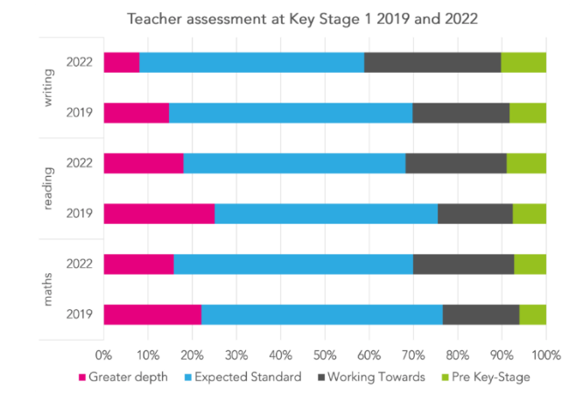  We were externally monitored at the end of KS1, June 2022.  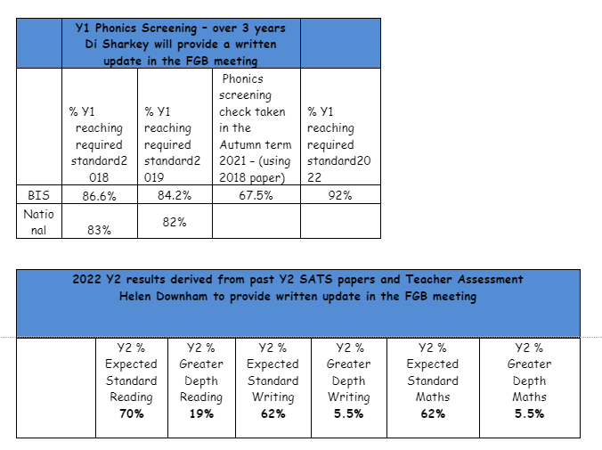 | Book Club has meant that every child is heard read every day either by a teacher or a TA. One of the five comprehension skills will be the focus each day.  The Maths Hub has brought more focus to how the lessons are interpreted and taught through the White Rose Scheme.  Teachers are using the squares more in their books with a focus on presentation.  In addition, Maths is being taught at the point of need.  We have enlisted the support of a literacy consultant to raise standards in English and to ensure that a consistent approach to the teaching sequence is implemented. We are focusing on transcription; in particular, handwriting, presentation and spelling.

Next Steps - Linked to School Improvement Plan
We need to review the marking and feedback policy to:
- reduce workload
- give instant feedback to the pupils and make their corrections meaningful.

Curriculum intent, implementation and impact are to be triangulated and monitored by the subject leaders using the impact monitoring cycle and the impact review sheet which ensures that the intent (planning) has been implemented into the learning (books and Google Classroom) and that the children can successfully talk about their progressive knowledge. The impact review sheet also identifies any areas for development that need to be addressed.

The retention and recall policy is evolving organically as the teachers explore and apply the research into strategies such as number songs that induce retention and recall. All of this together, means that all children know more, can do more and can remember more. In addition, each classroom has a learning journey wall which prompts the children to understand, remember and talk about what they know. Upon completion of a topic, the learning journey is transferred into a class book which children can access to revisit their learning and thus commit it to long term memory. One or two subjects will be the focus of each half term. This means that the children have a block of each subject over a 6- or 7-week period which also ensures that a logical sequence of learning is taught and remembered. Morning work is a carousel of activities focusing on: handwriting, spellings. maths, retrieval of the current topic, retrieval of the previous topic.

Behaviour and Attitudes
Judgement | GOOD

Evidence | Impact
Pupils are aware of and buy-in to the high expectations for learning as clearly outlined in the behaviour policy. | Research (the broken window theory) has shown that high expectations breeds high standards.  We have raised standards and now have a school we can all be proud of.
The pupils know where to access the school values which are the Secret to their Success, in their classroom and they want to take part in Success Time each Friday afternoon. Teachers acknowledge when the pupils have implemented one of the values and reward them through the Special Mentions Assembly. | The school values permeate through the daily lives of the pupils. The teaching staff highlight the values as they see them in use. For example: a pupil may have tried several times and not given up; the teacher may comment that the pupil has persevered and not given up. Therefore, the impact is that the pupils know and understand values in context.
There is a calm, purposeful atmosphere when the pupil’s transition around school as well as in lessons. Staff model high expectations around school and expect the pupils to emulate this. | The pupils understand that this is respectful and take a pride in the way they move around school.
Children support and care for each other. The Broomhill Ambassadors and our democratically elected School Council ensure that everyone feels heard. | We are a family, where no one is left out and where everyone is included. We make sure that everyone has a voice and is listened to.
Staff and pupils deal effectively with the very rare instances of bullying and / or any derogatory or aggressive language. | The impact is that we have cultivated a culture of inclusion, kindness and care for one another.
A creative curriculum with effective enrichment opportunities means that the pupils are enthusiastic about their learning. Indeed, the outdoor provision has proved to be instrumental in addressing well-being, mental health and regulating behaviour. | The impact is that pupils want to come to school and therefore their mental health and well-being improves.

Next Steps - Linked to School Improvement Plan
To improve further, we intend to:
- Monitor the unstructured times i.e. playtime and dinner time.
- Some of our Y2s will be Play Leaders at dinner times.
- Set up clubs at lunchtime.
- Make sure that everyone feels safe in school which is everyone’s responsibility.
- Make sure that the standards are upheld which is everyone’s responsibility.
- Ensure that attendance improves, which is also everyone’s responsibility.

Personal Development
Judgement | GOOD

Evidence | Impact
Pupils’ mental, social, spiritual, emotional and physical development and, within this, the promotion of the British and School Values, are at the heart of the school’s work, this is reflected in the curriculum - quality first teaching, topics, enrichment and visitors. | This has equipped our pupils to be thoughtful, caring, kind and active citizens in school, the local community and in wider society.
Pupils contribute to the life of the school and feel a sense of belonging. School council is active and we have Broomhill Ambassadors who give the pupils a voice. In addition, pupil voice is collected through questionnaires and through logging their reason for absence in the register. We also have a suggestion box that the School Council review. | The impact is that pupils feel heard and their ideas are taken seriously and debated.
Relationships in school are strong which significantly contributes to all aspects of school life including general behaviour, behaviour for learning and for safeguarding. The Zones of Regulation helps children reflect on their emotions and provides life-long coping strategies. | The pupils are now more able to find a mature approach to resolving differences and know where to seek help if they can’t do this themselves. The Zones of Regulation help pupils identify which emotion they are experiencing.
Social cohesion within the school is strong with children from a range of cultural and ethnic backgrounds along with pupils with a range of complex needs all understand and embrace differences. | The pupils understand and embrace differences and are inclusive towards one another and develop tolerance.
The PSHE / RSE (Jigsaw Scheme) curriculum provides opportunities for pupil voice and to consider relevant issues within the wider society, including Prevent. | The pupils understand and are able to articulate their views on topics within this curriculum. They are more informed and involved in discussion and debating skills whilst also developing their own opinions.
Pupils know how to keep themselves healthy. They make informed choices about healthy eating, fitness and their emotional and mental well-being. | They have an age-appropriate understanding of healthy relationships and are confident in staying safe.
The pupil’s safety is of paramount importance and therefore discussions around this topic are woven into and through our curriculum. In addition, we hold information evenings for parents to inform them of the potential online dangers and the inappropriate use of mobile technology. | Pupils have a good understanding of how to stay safe online and of the dangers of inappropriate use of mobile technology
Our Forest School provision promotes independence, confidence, well-being and working with others. | Pupils are equipped with the necessary skills to become well-rounded citizens by the time they leave us in Y2.
Visits, visitors and enrichment support personal development. For example, we have recently had visits from a disabled Olympic athlete, the Dogs Trust and a martial arts club. In school, we have enrichment such as Science and art club, sports clubs, yoga club, sewing club and poetry club | The impact is that pupils learn about the challenges that some people live with on a daily basis and how those people overcome the challenges they are presented with.  We also listen to our pupils and enlist clubs according to their interests.
Pupils have a strong voice and their contribution to school is promoted through the School Council, Broomhill Ambassadors, sports leaders, the daily register, pupil questionnaires and through class discussion and debate. | Pupils feel listened to and valued. Their contribution enables us to have a richer curriculum.
We have made some strong links to our community and have some fabulous community governors. Local businesses are very supportive with our fund-raising events and we get involved in local events such as opening our garden for the Broomhill Festival. Volunteers have been encouraged to come in to school and read or sew with the children or to help us with the upkeep of the garden.  We have recently forged new links with Broomhill Library. | This has brought our community into school and has enabled us to build the close community links we now have as well as encouraging our love of reading.
Here at Broomhill, we have 44 different cultures represented which we are very proud of and like to celebrate. We like to join in with the International Day of Culture, where we dress up in our traditional costumes and bring food from our country of origin to share with our class. Parents join us to talk about their culture. We display our country of origin on a world map in the foyer so that we can see where we all originate from. | The pupils are more knowledgeable about different cultures learn from their peers and from our parents.

Next Steps - Linked to School Improvement Plan
Through the school values and staff modelling high standards in manners, the pupils will become thoughtful, caring, kind and active citizens in school, the local community and in wider society.

We will listen to the pupil’s ideas so that enrichment will be more tailored to what the children would like to do.

We will strive to ensure that our Pupil Premium children have access to all areas of school life, including visits and other types of enrichment such as after school clubs.

Pupils will develop perseverance and resilience.

Pupils continue to be prepared for life in the modern world with a particular focus on being safe in the digital world.

Leadership and Management
Judgement | GOOD

Evidence | Impact
Staff have an unwavering focus on improving pupil outcomes through a visionary, systematic and collegiate approach | We have worked strategically to improve pupil outcomes. This includes prioritising and working collaboratively.
Governors challenge senior leaders so that the effective deployment of staff and resources, including the pupil premium, the primary PE and sport premium and special educational needs funding, secures excellent outcomes for pupils. | Our TLCC and Resources committees hold senior leaders to account over spending and quality of education. Regular committee meetings take place every 6 weeks.
Leaders and governors have an accurate understanding of the school’s effectiveness informed by the views of pupils, parents and staff. They use this to keep the school improving by focusing on the impact of their actions in key areas | The headteacher feeds back the questionnaire results termly. We have Working Together Committees to listen to our parents and harvest their suggestions.
Safeguarding is effective; policies and procedures are embedded and up-to-date. Any safeguarding issues are dealt with swiftly. All staff are aware that safeguarding is everyone’s business and know what to do to keep our children safe. All staff know that they should contact LADO via the safeguarding hub if they are concerned about another the conduct of another professional or volunteer.  The children feel safe at our school. | All staff are aware that it is everyone’s responsibility to ensure Safeguarding is our highest priority. Staff are aware of the policies and procedures in place when they have concerns.
The designated safeguarding leads have appropriate and up-to-date training. The annual safeguarding audit is completed and monitored regularly by SLT to ensure any outstanding assignments are addressed swiftly. | The safeguarding leads are confident to deal with any safeguarding concerns that are presented.
SLT ensure that staff recognise their shared responsibility in ensuring pupils attain the highest standards.  We do this by:  . dropping in to lessons on a daily basis  . setting and maintaining high standards  . sharing marginal gains in the weekly briefing  . feeding back as part of weekly staff meetings  . having a fortnightly meeting with support staff  . checking in daily with lunchtime supervisors.  . regularly inviting our school improvement partner in to help us review and do better.  . ensure that subject leaders meet with other leaders of the same subject across our cooperative of schools and with our locality.  . moderate to ensure a fair assessment.  . guiding our pupils to be thoughtful, caring and inclusive citizens, both in school and the wider community. | The impact is high standards, good communication with staff, realistic feedback from our school improvement partner and therefore, expectations are realised.
The leadership takes a democratic approach to making decisions so that the views of staff are always sought and often implemented. Similarly, all stakeholders have buy-in as they are always consulted. | Everyone has a voice and ideas and people are valued.
Curriculum planning is done together and with the Forest School practitioners. | The impact is that Forest School activities are explicitly linked to what the children need to know and that the sequence of learning is progressive.
Key Stage leaders have a key role in monitoring and evaluating the standards and quality of provision across their Key stage. | The Key Stage leaders are continuously monitoring and evaluating how the respective curriculums are being implemented and the impact of this. They ensure that timely assessments are undertaken and that statutory tests are delivered for the most conducive outcome in small groups.
Leaders monitor and evaluate the performance of the school and use this knowledge strategically to set clear goals for improvement. Through Pupil Progress meetings, gaps are identified and those children then receive interventions targeting the gaps in their learning. | SLT regularly review the SIP. We plan, do, review and tweak as necessary. We quality assure by inviting our school improvement partner in to assist in this process.
CPD and performance management are clearly linked to the school’s improvement priorities whilst also addressing individual development needs. They are clear and can be measured for impact. This year our main priorities are: The wider curriculum, maintaining high expectations and consistency in Teaching and Learning and improving attendance. Performance management links to the school improvement Plan according to the subject leader’s area of expertise. Learn Sheffield provides leaders and governors with quality CPD. | Teaching and Learning: We are constantly improving and refining.  Attendance: Persistent Absentees are held to account.
Subject leadership is excellent and subject leaders have fully embraced the curriculum developments with the arrival of the new headteacher. | With the arrival of the new headteacher, the subject leaders have been supported in the development of the wider curriculum, writing subject policies, creating well though-out and logically sequenced progression of knowledge and skills documents and assessing the impact of what has been taught (has it been remembered)
The new headteacher is very strong leader who understands the strengths of the team around her. | The staff may express interest in a particular subject so the headteacher always listens to preference before making a decision.
The staff team are supportive of one another and the headteacher has regular meetings with all staff to ensure that there is a staff voice. | As documented earlier.
The headteacher recognises that staff well-being is important and seeks to ensure that everyone feels valued and is listened to. | Staff are appreciated and valued.
The headteacher has a democratic approach to leading. | We have a wealth of experience within the staff team which is valued and utilised by the headteacher.
The school has an outward looking and collaborative approach and works in partnership with Learn Sheffield, Locality F, with a working group of six schools known as The Sheaf Cooperative Learning Trust and Infant Head teachers across the City as well as our feeder school. | The headteacher appreciates the wealth of knowledge and experience that is gained from working collaboratively with these groups.

Next Steps - Linked to School Improvement Plan
Next Steps are:

- Continue to lead strategically.
- Continue to develop a clearly structured and sequential curriculum that is ambitious for all pupils and embeds key concepts in their long-term memory.
- Ensure that CPD is focused on subject, pedagogical and pedagogical subject knowledge leading to improved outcomes for more able, SEND and EAL pupils
- Further develop the SEND Provision Map to make the most effective use of funding and to ensure quality education and an ambitious curriculum for all.

Early Years Foundation Stage
Judgement | GOOD

Evidence | Impact
Foundation Stage is always full and oversubscribed. | The impact that our provision has had is that people want to bring their children to Broomhill for their education.
LA moderators along with monitoring and evaluation clearly illustrate that the aims of the EYFS are met in all areas of learning. | Everything is triangulated to ensure robust systems and processes are in place.
The EYFS team cultivate solid foundations in the following areas:  - Transitions  - Partnerships with parents (daily information sharing)  - Accurate baseline assessment  - Appropriate and timely interventions.  We have recognised that transition time is an anxious time so we have tried to alleviate as much anxiety as we can with home visits, several visits to the provision, transition booklets and an information pack with everything the family might need to know. | Parents can feel confident that they receive all the information they need.
Across school, there is close communication and a consistent approach to teaching from EYFS to Y2. Subject leaders have mapped out knowledge progression from FS2 up to Year 3. | The impact is that we know the prior learning and the learning that our Y2 children will move on to. We have a solid understanding of what our children need to know and we sequence it progressively.
The team considers the cultural capital. We are interested in our pupils and their interests. | We give our pupils the knowledge that they need to prepare for their future success. We give our children the best possible start to their early education.
There is a consistent approach to teaching systematic synthetic phonics and Book Club across school from EYFS to Y2.  Because we have whole class phonics and then grouped Book Club lessons, we get the best of both worlds. We get the Quality First Teaching from the phonics and the benefits of reading a closely matched book with our peers in Book Club. Our adults listen to every child read, every day. | At Broomhill, we breed success. Because our children feel successful at reading, they then to love to read.  Reading has improved because of this strategy.
The characteristics of learning are closely linked to the Secrets to our Success.  Focusing on a school value each half term, helps the pupils understand what the school values are, why they are important and how they fit into our lives. In addition, the staff at Broomhill might ‘catch’ one of the pupils doing one of the values. This is celebrated in the Special Mentions Assembly. It models to our pupils that we live by our values. | The impact is that the children understand the important values that we live by and understand what they mean in everyday situations.
The planning for the EYFS curriculum links directly to the whole school progression (we plan together as a staff team). | As explained earlier.
The Reception children take part in all of the whole school activities and celebrations. | Everybody feels included.
The learning environment links to that which the pupils need to know as well as having the usual staple of a home corner, reading corner and construction area.  This gives the children investigative activities linked to the learning and the vocabulary which accompanies it. | The pupils can talk about their learning using appropriate vocabulary.
The outdoor environment is used to extend and support indoor learning, with a focus on gross motor and other prime areas. | The pupils get plenty of practise developing their core strength and gross motor skills in their outdoor area.
Communication and Language skills is a key focus – to support all children including children with EAL and SEN. | Our children are given the tools to succeed.
Our Forest School provision extends the learning outside and is a fantastic resource for mental health and well-being. | You can literally see the children flourish in Forest School.
Children have pre and post teach and next steps are delivered in the moment. | Gaps are identified and plugged either in the moment of teaching or as a pre or post teach.
Storytelling and language development is supported by the ‘immerse’ part of our English teaching sequence. | Our children can re-tell the story expertly before they write.
Planning is done in partnership with KS1 (a whole school approach).  Subject leaders get additional time to monitor the impact of what has been taught. They look at planning, books and assess what the children can remember. | We all understand the prior learning and the subsequent learning.

Next Steps - Linked to School Improvement Plan
In the Early Years, we are working on making sure that the children have access to topic related vocabulary within the continuous provision, that the provision is linked to what the children need to know and, wherever possible, an adult is there to model the language associated with the activities.

The whole school focus is on handwriting, spelling and teaching maths at the point of need so we are starting with high standards and work that the children can be proud of and can talk about. Morning activities in EYFS reflect this focus as well as maintaining the high standards in everything we do.

Overall Effectiveness
Judgement | GOOD

Evidence | Impact
This is because Broomhill is a unique and special school. Education at Broomhill is alive, rich and relevant. Outcomes for children at the end of Reception and KS1 are in line and if not, better than the national figures.  September 2022 baseline assessment and gap analysis informs interventions and additional support for pupils. | Children are engaged with the memorable learning and have fun whilst learning new skills.
Broomhill is a safe place for the children, both physically and mentally where bullying or racism is not tolerated. Indeed, we have created a climate of safety, where all children feel included and safe from bullying, fighting or unkind words. | Any incidents of concern are taken extremely seriously and dealt with swiftly so that our children can feel safe and happy at school.
It is a place where the children can experience our Forest school provision (a magical provision that enables the children to be ‘at one’ with nature and to enhance their learning). | The children are enthused about their learning and some children, for whom learning in a classroom setting is challenging, find this a more agreeable setting in which they can learn and remember more.
Along with our extra-curricular activities, our extremely creative and caring staff team and our consideration of the pupil voice, ensure that our children feel like they have had a say in their own learning. | The children feel listened to and valued.
Our community is richly diverse and each family is given the opportunity to come into school and tell us about their culture. We have Mystery Reader, where parents read to their child’s class, we have ‘Working Together Committees’ where we share concerns with parents and work together to resolve them (recently, we have had working together committees to tackle poor attendance and punctuality). We pride ourselves on being an extremely supportive community and take part in community events such as Remembrance in Weston Park or the Broomhill Festival. | Our community feels included and involved in the life of our school.
Here at Broomhill; we strive to ensure that our children, staff and families are happy. Our teaching staff go above and beyond to make sure that the foundation of each school day is that the children are and feel safe and happy. | The children love coming to school.

Next Steps - Linked to School Improvement Plan
The next steps are:
- We will continue to develop our wider curriculum, taking on board the reviews from curriculum leaders when we plan.
- We will ensure that standards remain high and outcomes are at least in line with National for the core subjects.
- We will continue to build relationships with our families and provide support to enable children to be in school and attendance to improve.
- We will continue to listen to all of our stakeholders in order provide our families and our community with the best offer we can.

