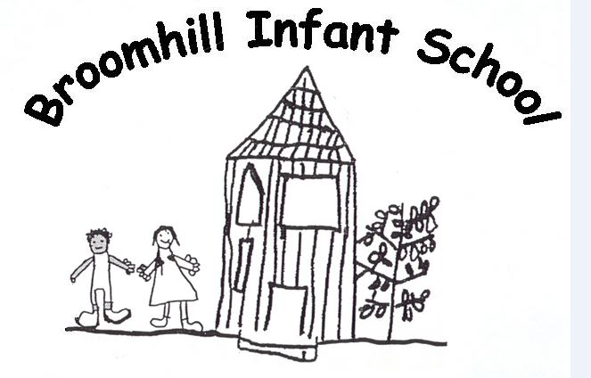

27/09/22

Dear Parent/Carer

Basketball After School Club for Yellow, Green and Blue

There will be a Basketball afterschool class from 3:10p.m until 4:00p.m every Wednesday, starting 11th October for 4 weeks until the 8th November. There will be a small charge of £5 per child per session – a total of £20 for the 4 weeks.

Please return the slip below and you will be contacted if your child receives a place.
Kind regards

Jane Barnes
Head Teacher
…………………………………………………………………………………………

Basketball After School Club 11/10/23 – 08/11/23

My child……………………………………………………………………..Base………………………………………..……….

Would like to attend Basketball Club.

Please do not send any money until a place has been confirmed for your child.

Signed Parent /Carer …………………………………………………………………….

