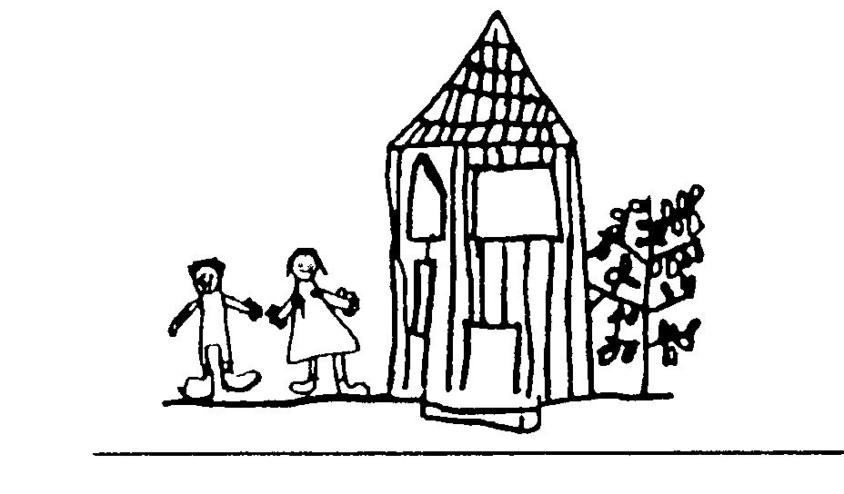
Intent
Broomhill Infant School
Subject Impact Review:
Implementation
Impact
Intent | Implementation  Is the statement of intent evidenced in the children’s books? | Impact
To know | FS2 -
 | Year 1-
 | Year 2 –
To know | FS2 -
 | Year 1-
 | Year 2 -
To know | FS2 -
 | Year 1-
 | Year 2 -
To know | FS2 -
 | Year 1-
 | Year 2 -
To know | FS2 -
 | Year 1-
 | Year 2 -
To know | FS2 -
 | Year 1-
 | Year 2 -
Actions | None

